red red red red red
red
violet blue green yellow orange

orange orange orange orange orange
orange
red violet blue green yellow

yellow yellow yellow yellow yellow
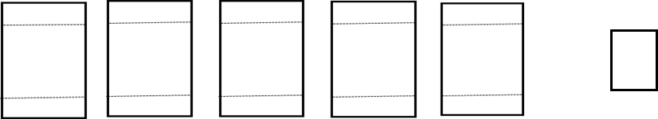
Name_______________________________________________________________ per._________ days_________
Color Blending Worksheet
Complete the chart by blending one color to the other in the area between the dotted lines
yellow
orange red violet blue green

green green green green green
green
yellow orange red violet blue

blue blue blue blue blue
blue
green yellow orange red violet

violet violet violet violet violet
violet
blue green yellow orange red

